Key Issue 1: Where Are Migrants Distributed?
Pages78-83

***Always keep your key term packet out whenever you take notes from Rubenstein. As the terms come up in the text, think through the significance of the term.
- Define immigration:

- Define emigration:

- Using figure 3-1, briefly state what one would expect to occur, in terms of migration, in each stage of the demographic transition model, as it is applied to a migration transition.

MIGRATION TRANSITION
As Applied to the Demographic Transition Model
Stage 1 | Stage 2 | Stage 3 & 4

- What are Ravenstein’s two laws for distance in relation of migrants?

- Migration may be classified as either international or internal. What is the difference?

- What types of push factors are usually responsible for voluntary migration?

- What types of push factors are usually responsible for forced migration (refugees)?

- Define interregional migration:
- Define intraregion migration:

- Read the section, International Migration Patterns on page 81, and then make 5 summary statements regarding global migration patterns.

- Finish this statement: The world’s third most populous country (the U.S.) is inhabited overwhelmingly by…

- In what stage of the Demographic Transition are most countries that send out immigrants? (Think this through…)

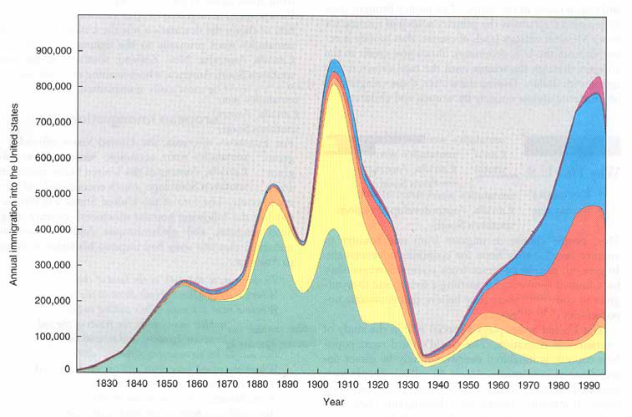
- Annotate the graph below from your reading of pages 82-83. Be sure to label all “peaks” and “valleys” (as indicated by arrows) as to where immigrants came from during that time or why there was a decline in immigration.
- What are the three countries that sent out the most immigrants from Asia in recent years?

- What caused immigration from Latin America to the United States to increase?
- Although the reasons people leave their countries to immigrate to the U.S. have not changed over time, what has changed here in the U.S.?

Key Issue 2: Where Do People Migrate Within a Country?
Pages 84-91
- What is the most famous example of large-scale interregional migration in the U.S.?

- What is the “population center” (see Figure 3-9)?

- What was the first intervening obstacle which hindered American settlement of the interior of the continent?

- What developments in transportation eventually encouraged settlement to the Mississippi?

- Why was settlement of the Great Plains slow to come with settlers passing it by for California and the west coast?

- How did the railroads encourage settlement of the American interior?

- For what two reasons have people been migrating to the South in recent years?

- Use the chart on page 85 to calculate the net growth or loss of U.S. regions for 2010. Name the region on the map and place the appropriate number in each region.
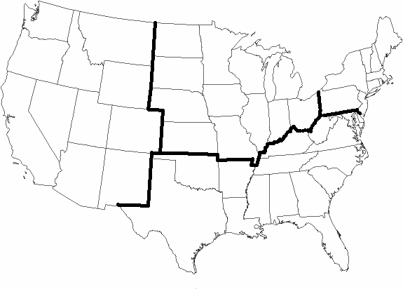
- Make appropriate notes in the chart below on 5 specific examples/case studies of interregional migration.

Russia
Where? | Why?
How?

Canada
Where? | Why?
How?

China
Where? | Why?
How?

Brazil
Where? | Why?
How?

- Define/describe each of the following terms, and summarize a single, important fact about its occurrence in the U.S.
 | Urbanization | Suburbanization | Counterurbanization
Definition
Significant Fact
in U.S.

Key Issue 3: Why Do People Migrate?
Pages 92-95

- What are push factors and pull factors?

- Complete the chart below with specific examples of push and pull factors and where people are being pushed from and pulled to.
 | Push Factors | Pull Factors
Political
Environmental
Economic

- Define guest worker:

- Explain why China and Southwest Asia are major destinations for migrants.

Key Issue 4: Why Do Migrants Face Obstacles?
Pages 96-103

- Define intervening obstacle:

- Briefly describe the role of physical geography in examining intervening obstacles and migration.

- Briefly describe the role of transportation in examining intervening obstacles and migration.

- Briefly describe the role of political concerns/laws in examining intervening obstacles and migration.

- What did the Quota Act (1921) and the National Origins Act (1924) do?

- How did they favor immigration from certain regions?

- How did the Immigration Act of 1965 change the existing quota laws?

- How was immigration law further changed in 1978? And presently?

- U.S. immigration law gives preferences to groups. Identify those preferences.

- Define brain drain:

- Define chain migration:

- What are undocumented immigrants?

- Where do most undocumented immigrants in the U.S. come from?

- Complete the following chart from the reading about migrants.
Characteristics of Migrants
Gender
Age
Education

- Complete the following chart about the four major elements of immigration law in the U.S.
Immigration Law
Border Patrol
Workplace
Civil Rights
Local Initiatives

- As you read pages 100-103, complete the Venn diagram below to compare and contrast attitudes in the U.S. and Europe toward immigrants.
U.S. Attitudes Toward Immigrants | European Attitudes Toward Guest Workers
- Discuss the impact of Europeans emigrating around the world.

